SE161225_SWE201c_PE_SOURCE
(Dan chung tu de bai duoc in nghieng)
Q1. Muon sai cai nao cung duoc
For Scrum:
I suggest software development methodology is Scrum for this situation, because:
-Requirements: it is not clear about the functional requirements, because the functionality is not specific about a feature that is somewhat confusing such as:
+ Embedding GPS Tracking for Real-Time Arrivals: People are currently wasting time guessing at train or bus schedules. Travelers can view real-time arrival updates from the transport media by using the GPS tracking feature…etc.
+ Map and Navigational Tools for the Guide: Include a geolocation map for the city’s specialized public transportation services in the transportation app and give customers real-time navigational assistance for their travel needs.
+ A schedule and offline routes are available: All frequent commuters who follow a set route, set of stations, and set of places enjoy offline viewing…etc.
- About Scrum, it will be suitable for projects with complex features, and many requirements
- Team size: “A start-up company desires to develop an application with more features to bring more convenience to travelers.”, we just know about that is a start-up company, so team size medium it will be suitable for using Scrum.
- Since this is a start-up company, they will be able to be a multi-tasker such as a developer who will probably take care of software testing.
- Detect and correct errors early.
- Scrum is suitable for projects where customer needs are not clear from the start.
- Customers take a quick look at the product for early feedback.

=> With what I mentioned above, I feel that the model Scrum is one of the most suitable methods in this situation because it's not clear yet, the startup likely won't hire many experienced employees, can detect bugs early, get feedback from users to improve.
=> To sum up, I think Scrum model is one of the most suitable methods in this situation, because it is not clear that startups are unlikely to hire many experienced employees, who can catch bugs early, can get feedback from users to improve. (Tranh dao van)

For Lean:
I suggest the software development methodology for this situation is LEAN development, because:
- Reliability: the requirements (needs) of the customer are quite clear and highly reliable.
- Types and number of requirements: the requirements contain both non-functional and functional requirements, the requirements are very clear and not vague. They know the user’s need, know the solution because the list 4 key features of the system and they also know types of users that may make use of the application.
- Being based on customer tastes and needs is the key to producing commercial products. Developers use feedback to create a future development roadmap.
+ As more users invest time in studying and preparing for their upcoming major trips or business destination, there are an increasing number of travel apps available for iOS and Android devices.
+ Given the 1700% increase in mobile bookings in the travel sector since 2015, it is predicted that 31% of all travelers will research and book their upcoming trips using a smartphone or tablet.
+ Being lost in an unfamiliar airport can be very confusing. Therefore, users can benefit greatly from detailed maps that illustrate how to go to a necessary gate or terminal in real-time.
- It consists of implementing a product with a minimum feature set, sufficient to satisfy the initial users: A start-up company desires to develop an application with more features to bring more convenience to travelers.
=> To conclude, because the system is defined in 4 key features, and developer based on customer tastes and needs is the key to producing commercial products. Developers use feedback to create a future development roadmap. The requirements of the system are complete, clearly defined, and easy to understand. So. LEAN DEVELOPMENT is suitable for applying to this project. It helps build and perfect product steps step by step based on the change of the customer. Plus, it's less costly to change requirements and easy to manage risk because the developers learn from needs and direct feedback from customers create the necessary preparation for risks.
=> All in all, since the system defines 4 main characteristics and developers based on customer taste and needs are the key to produce a commercial product. Developers use feedback to create a roadmap for future development. System requirements are complete, well-defined, and easy to understand. Therefore, LEAN DEVELOPMENT is suitable for applying for this project. It helps to gradually build and refine the product as customers change. It is also less expensive to change requirements, and it is easier to manage risk because developers learn from requirements, and direct feedback from customers creates the necessary risk readiness. (Tranh dao van)

For waterfall: (Nho them dan chung tren de vao)
As a leader in academic event management, I recommend using traditional development methods for this situation, especially the waterfall method.
The reason is
+ This is just a small project (4-6 features for a team of 4 developers) and will take 2 weeks to complete.
+ Requirements are clear enough.
+ There are not many requirements, including functional requirements and non-functional requirements.
+ Requirements rarely change.
+ Requirements can be defined at an early stage.
+ The team is small (4 developers, 2 testers) and the level of understanding is not very high.
+ Easy to use, address, manage.
+ The development of the product is clearly defined at each stage.
+ Every stage of product development is validated, making it easy to identify and fix bugs.
- The software development methodology I propose for this situation is WATERFALL. This is a new project with clear requirements. We are software development experts in the industry. So, I think the waterfall method is suitable for this situation.
Q2.
List out 4 functional or non-functional from De bai
*Để làm được câu này ta phải biết functional requirement và non-functional requirement là gì?
Functional requirement (Yêu cầu chức năng):
-Có nghĩa là cái hệ thống này nó phải có cái gì ? Nó phải làm được cái gì ? Có những chức năng gì ?
VD : Send SMS, Zalo , View List, Add, Remove,…etc.
Non-functional (Yêu cầu phi chức năng):
-Nó sẽ trả lời cho câu hỏi là « như thế nào »
-VD : +Nó sẽ có « màu như thế nào ? » (Cụ thể là những tính từ)
+ “ Tốc độ nhanh hay chậm?”
+”Bảo mật hay k?”
+”Viết = ngôn ngữ gì?”
+”Chạy trên hệ điều hành ntn?”
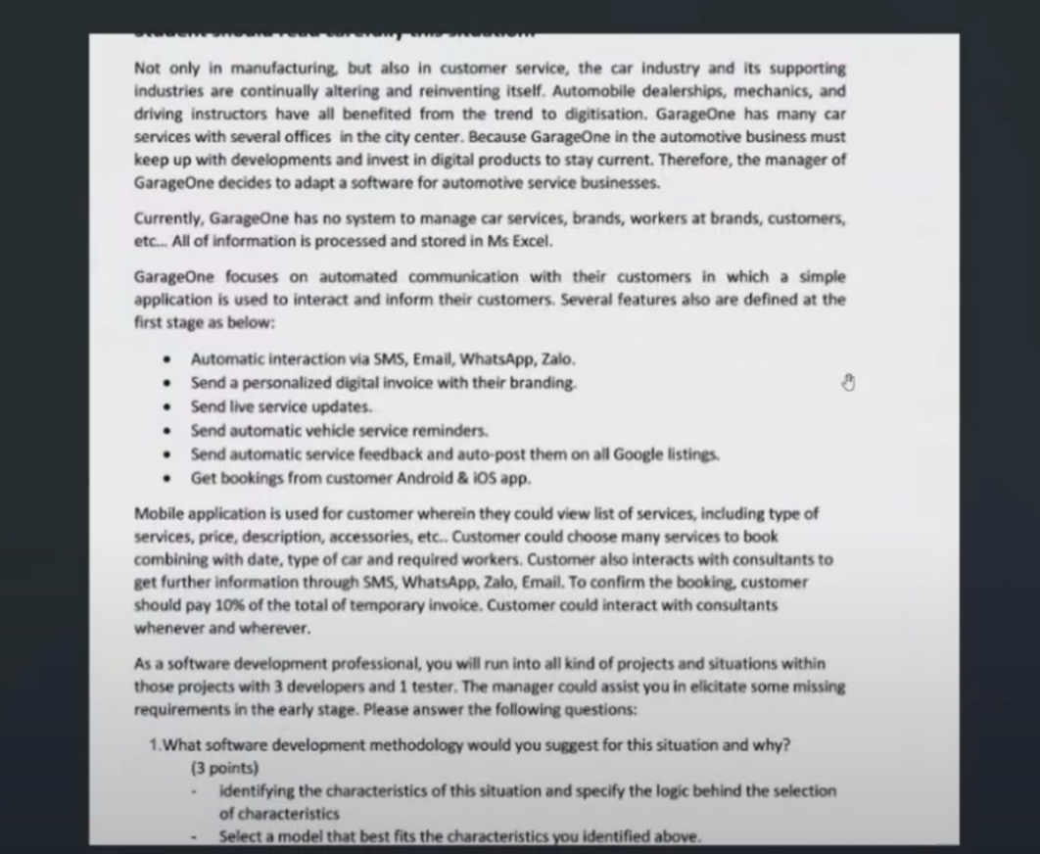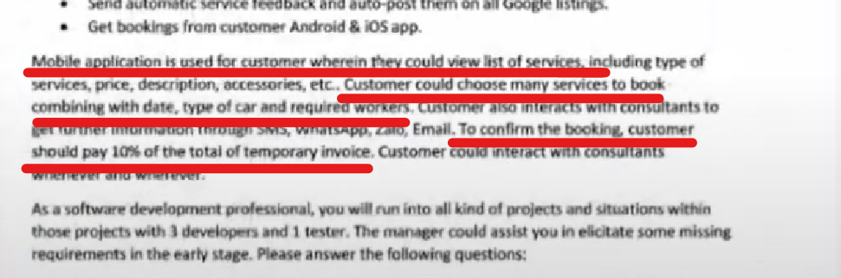
Giải:
4 Functional requirement (Yêu cầu chức năng):
Nhìn vào phần “FEATURES” ta sẽ tìm được “Functional requirement “ (1đ cho ý 1)
-Automatic interaction via SMS, Email, WhatsApp, Zalo.
-Send a personalized digital invoice with their branding.
-Send automatic service feedback and auto-post them on all Google listings.
-Get bookings from customer Android & IOS app.

2 Non-functional (Yêu cầu phi chức năng):
-All of information is processed and stored in MS Excel.
-To confirm the booking, customer should pay 10% of the total of temporary invoice.
Q3.
Cau truc: As a …..., I want to ……. (So …….).
Câu này sẽ nằm ở đoạn quanh đây vì câu hỏi là user stories of customer
Còn nếu câu hỏi là của hệ thống thì sẽ nằm ở phần trên (chỗ functional requirement)
LÝ THUYẾT:
User stories of customer: người nào…. Làm vc gì… với mục đích gì….
As………….., I want to……………., so…………………..
Ai cái gì mục đích
User stories of systems: người nào…. Làm vc gì… với mục đích gì….
As………….., I want to……………., so…………………..
Ai cái gì mục đích
VD: As a manager’s system, I want to……….

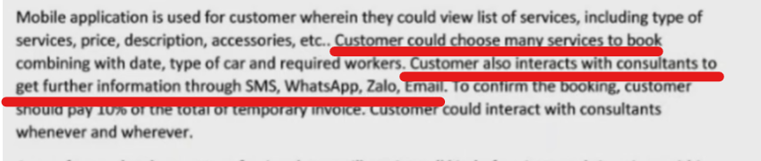

Giải:
- As a customer, I want to choose many services to book combining with date, type of car and required workers
- As a customer, I want to interact with consultants to get further information through SMS, WhatsApp, Zalo, Email.
-As a manager, I want to record technical workers tasked done so that I could assign/re-assign with other tasks
-As a manager, I want to view the statistics in best-seller so that I know what service that customers prefer most
Q4. Cau nay nen lam cuoi cung vi rat mat thoi gian
Travelers
Login | Search for destinations and itineraries |  | Reminders and push notifications about upcoming check-ins |  | Add destination videos, with travel recommendations |  | Store tickets
Login to the system(  Access the system by logging in.) | Input destination for search(  Enter the destination to initiate the search.) | View rout best route to go to this destination(Explore the optimal route to reach this destination.) | Check travel upcoming information(Review upcoming travel information) | Reminder for each time duration(Set a reminder for each specified time duration.) | View recommendations  Destination(Display recommendations for the specified destination.) |  | View detail tickets
Enter the username, password on the app  (Provide the app with your username and password.) | Using current location for quickly searching(Utilize the current location for a prompt and efficient search.) | List vehicle to go(Enumerate the available vehicles for transportation.) | List notification up to time(Display a list of notifications up to the current time.) | Remind for each hour, day(  Create a reminder for each designated time interval.) | List all the destination that most travelers arrive | View rating | List tickets by airland or another vehicle.(  Provide a list of tickets for air, land, or other transportation options.)
Fast login by using phone number, Gmail, or another social media  (Swiftly log in by utilizing your phone number, Gmail account, or another social media platform) | Show information about destination(Display information about the destination.) | View total time to get this destination(View total time to get this destination) | Show detail of the information(Provide detailed information about the specified details.) | Turn on or off reminders(Enable or disable reminders.) | View number of visitors | Sort by rating | Search tickets by brand, by time purchase
Scan QR code to login(Authenticate by scanning the QR code for a quick login.  ) | Show rating star about this destination(Present the star rating for this destination.) | Feedback for wrong destination(Provide feedback for an incorrect destination.) |  |  |  |  | Feedback to ticket’s brand

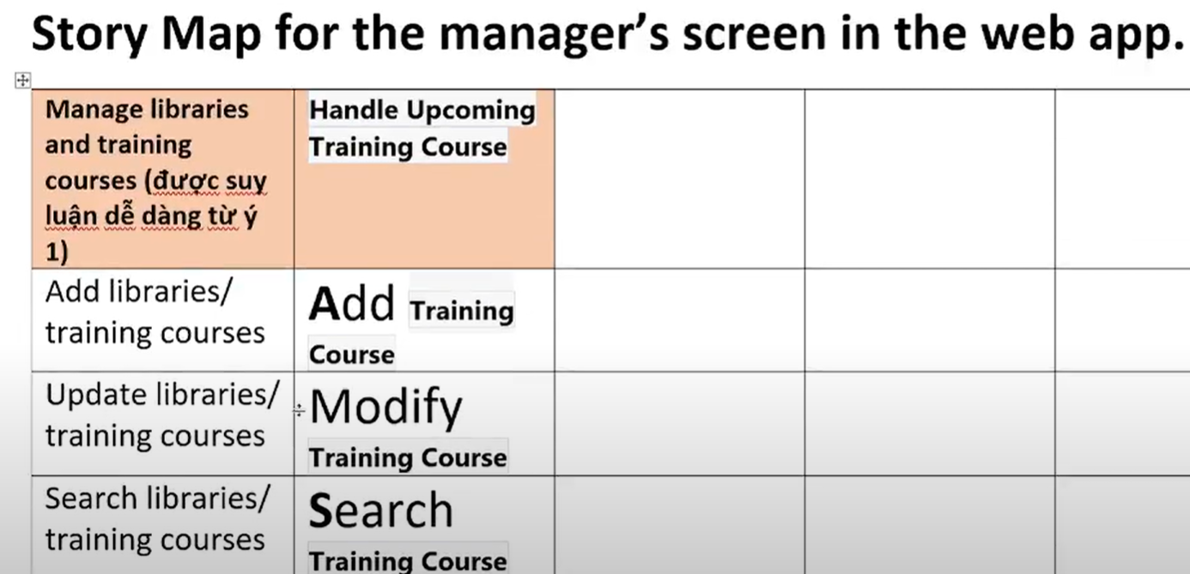
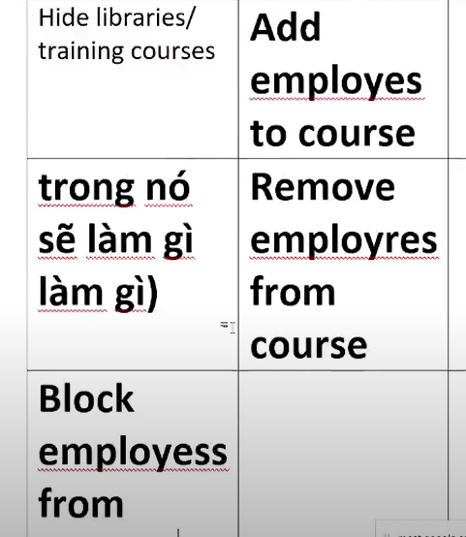
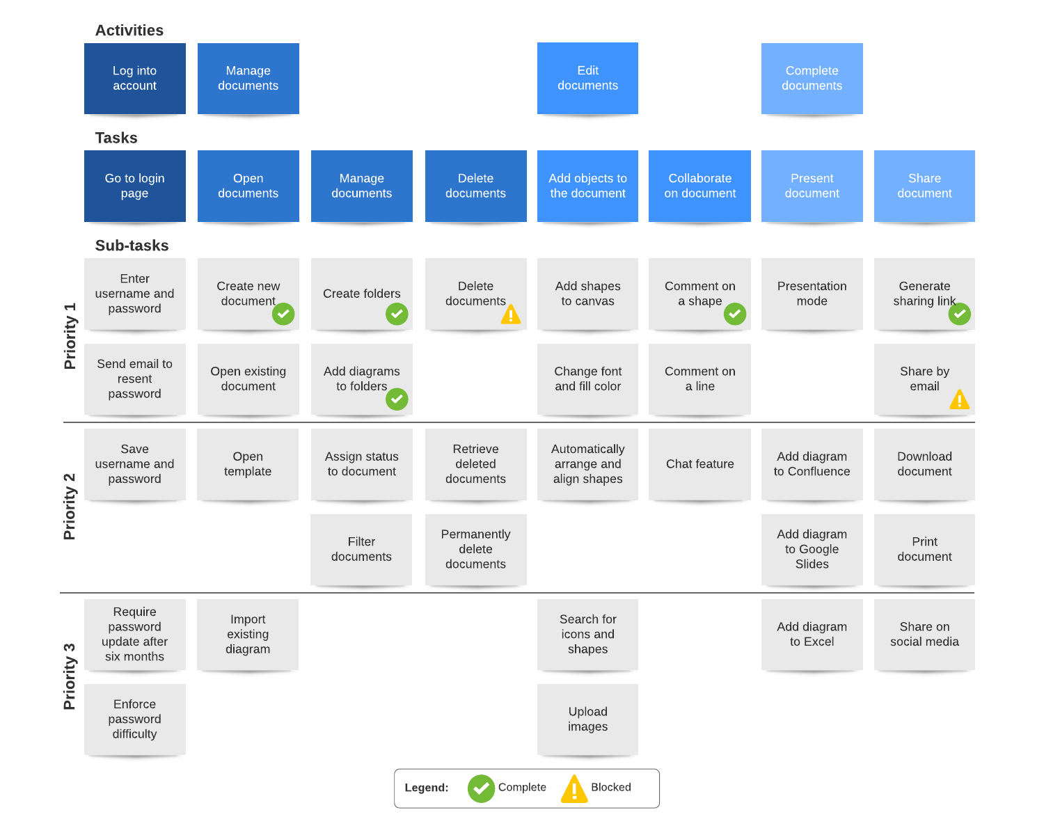
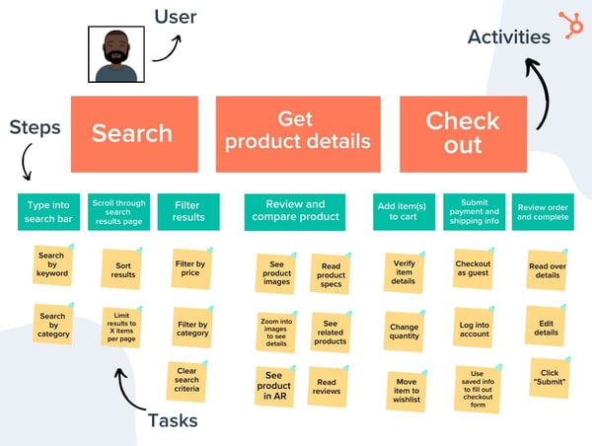
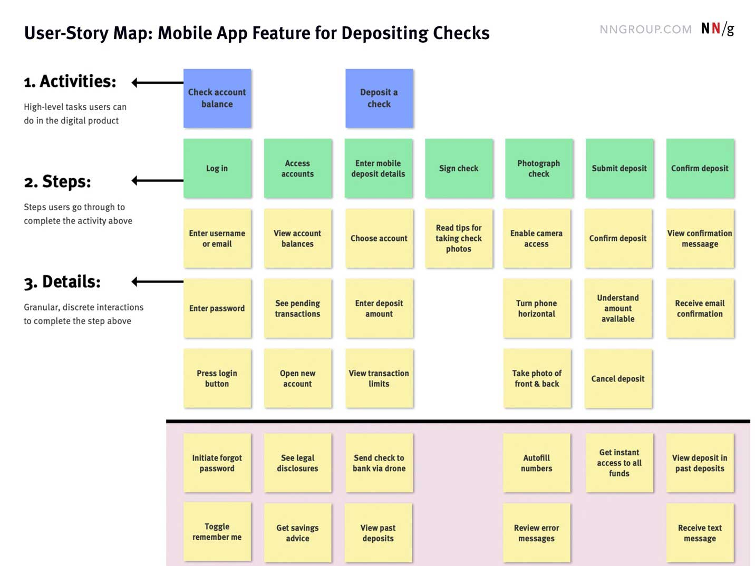
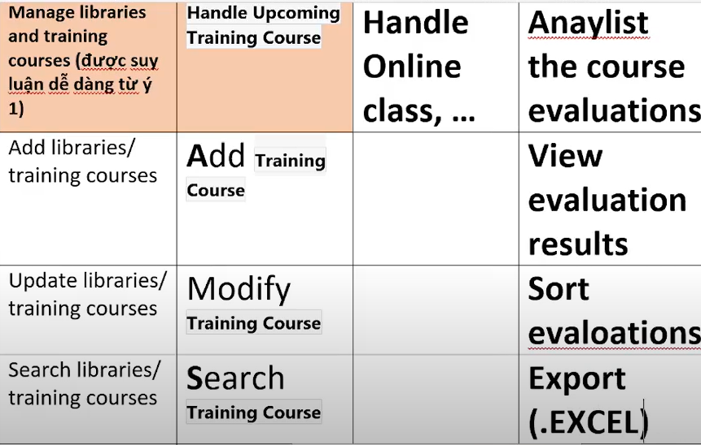
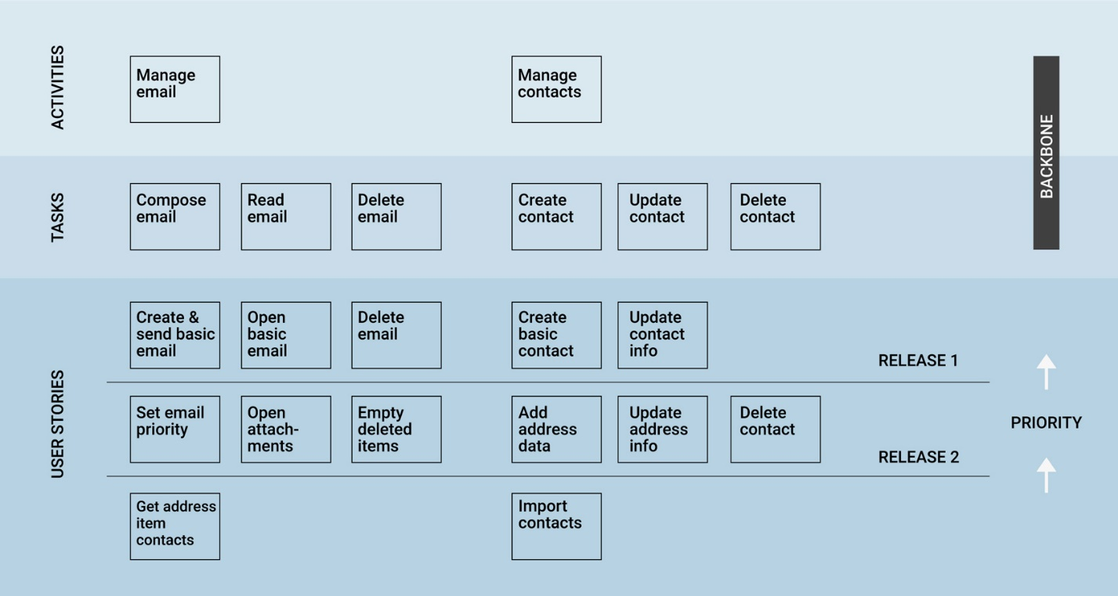
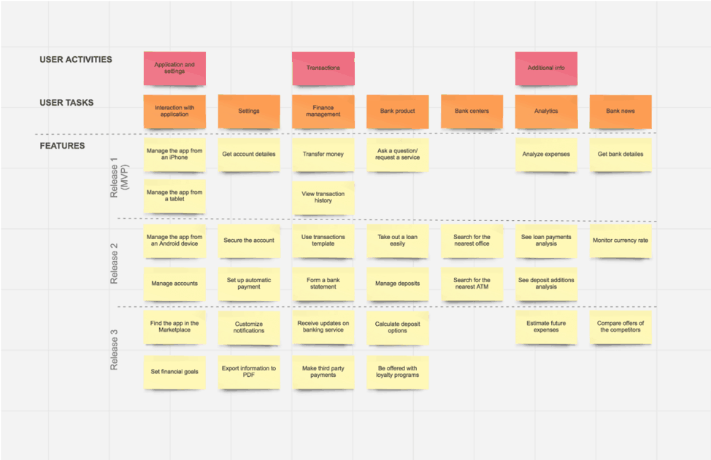
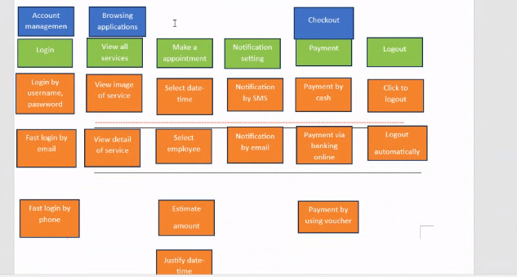

Q5. De noi trung dap an ben duoi thi agree luon
For Scrum:
a. I don’t agree with this requirement. Because:
+ About Scrum, it will be suitable for projects with complex features, and many requirements
+ Scrum will work at its best in a multifunctional team of 5 to 9 employees, and the developer works on a medium to large-scale project (from 4 or 5 months to years).
+ A person can perform multiple functions, many different jobs such as dev can play the role of test.
+ Easily detect errors to handle
+ Scrum is applicable to projects with unclear client requirements from the start.
+ Customers will quickly see the product so that they will be able to give early feedback.

+ Regarding Scrum, it is suitable for projects with complex functions and many requirements
+ Scrum works best in multifunctional teams of 5 to 9 people, with developers working on medium to large projects (from 4 or 5 months to several years).
+ One person can perform multiple functions, many different jobs like a developer can play the role of a tester.
+ easy to detect errors to handle
+ Scrum can be used on projects where customer needs are not clear from the start.
+ Customers can quickly see the product to be able to provide feedback at an early stage.
(Chong dao van)
b. I suggest Blackbox testing for the team.

For Lean:
a, I will not agree with the requirement that using WATERFALL METHODOLOGY because it’s based on customer tastes and needs is the key to producing commercially products. Developers use feedback to create a future development roadmap. If we use WATERFALL METHODOLOGY, the application will less flexibility, limited scope of adjustment, difficult to measure development in each stage and the model is not suitable for long, ongoing projects, or complex projects, with many changes in requirements in the development life cycle. Otherwise, if we use LEAN DEVELOPMENT, it will help build and perfect product steps step by step based on the change of the customer. Plus, it's less costly to change requirements and easy to manage risk because the developers learn from needs and direct feedback from customers create the necessary preparation for risks.

I don't agree that using WATERFALL METHODOLOGY is a key requirement to make a commercial product as it is based on customer taste and needs. Developers use the feedback to create a roadmap for future development. When we use WATERFALL METHODOLOGY, the application becomes less flexible, the scope of customization is limited, it is difficult to measure the development of each stage, and the model is not suitable for long-term, ongoing projects or complex projects where the development life cycle requires many changes. Otherwise, if we use lean development, it helps to gradually build and refine the product according to customer changes. It is also less expensive to change requirements, and it is easier to manage risk because developers learn from requirements, and direct feedback from customers creates the necessary risk readiness.(Chong dao van)

b, I suggest Black-box testing for this project because in this project, we have functional requirements and non-functional requirement is clear; It helps the testing process is easier and soon to prepare if not suitable for the needs of user.

I recommend black box testing for this project, because in this project we have functional requirements and non-functional requirements are clear; it helps to prepare easier and faster when it doesn't fit user's needs Testing process. (Chong dao van)

